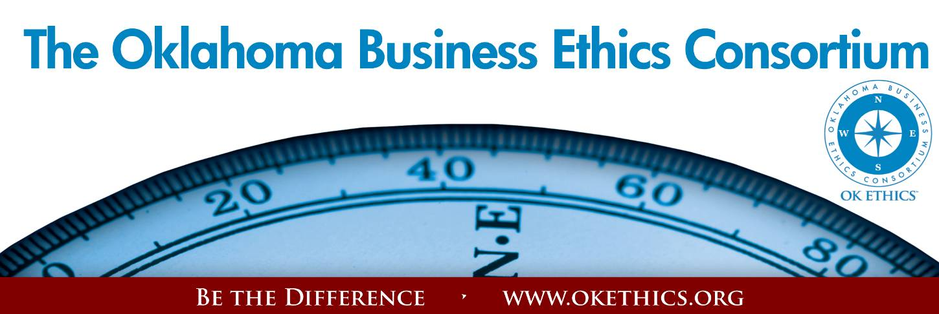
Agenda – April 18, 2012
- Kudos & Upcoming Events – Garyl Geist, Chief Operating Officer, Oklahoma Asthma
& Allergy Clinic; President, OK Ethics Board of Directors
Special appreciation to our co-hosts:
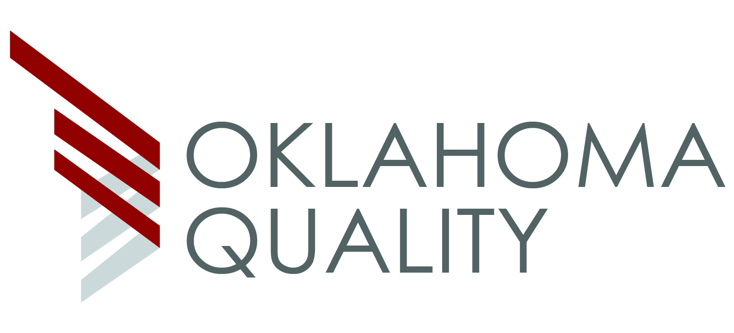
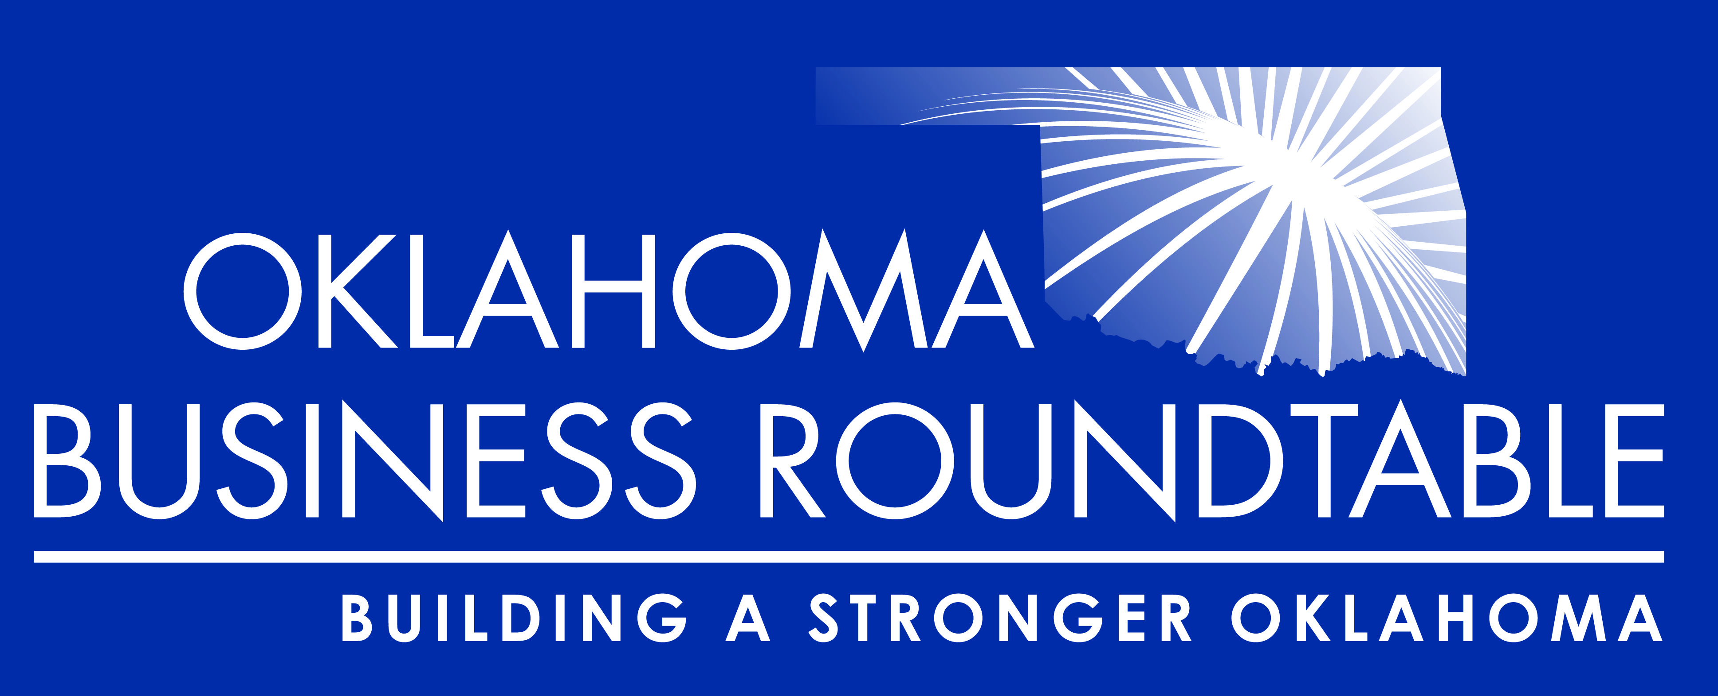

- Words of Inspiration- Dr. Bob Long, Senior Pastor, St. Luke’s United Methodist Church
- Executive Pilot Award – Janice Dobbs, (Retired) Devon Energy; Director Emeritus, OK Ethics Board
J. Larry Nichols, Co-Founder & Executive Chairman of Devon Energy
- Compass Award: Mid-Sized Company – Carla Brockman, Vice President of Corporate Governance &
Secretary, Devon Energy; 2012 OK Ethics Compass Award Selection Team Member
Honorable Mention:
- HoganTaylor LLP (Oklahoma City & Tulsa)
- Ideal Homes of Norman
- Pelco Products, Inc. (Oklahoma City)

Award Recipient: MESA™ – Chief Executive Officer, Terry May

- Compass Award: Large Company Category – Oscar Jackson, (Retired), State of Oklahoma,
Office of Personnel Management; Charter Member of the OK Ethics Compass Award Selection Team
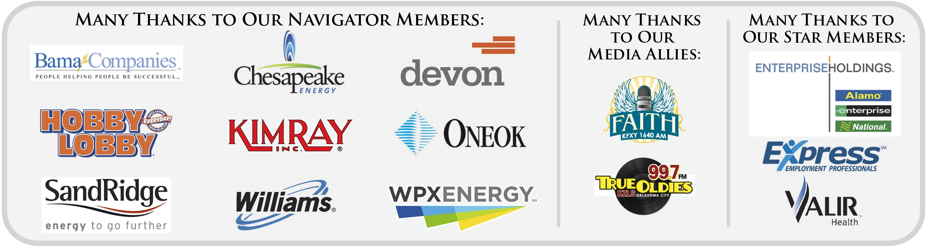
Community Impact Award: ONEOK – Edith Steele, (Retired) Oklahoma Accountancy Board;
OK Ethics Compass Award Chairperson
Award Recipient: OGE Energy Corp – Gary Huneryager, Vice President of Audits
& Chief Ethics Officer

- Introduction of Speaker – Todd Lisle CPA, Managing Partner, BKD, LLP; OK Ethics Board of Directors
- Keynote - “Smart Trust” – Stephen M. R. Covey
- Adjourn (1:15) – Shannon Warren, Founder, OK Ethics
Books are available for signing at Threefold Bookstore in the Church Narthex
Cost $30 each; Express line at welcome desk for cash/checks payable to St. Luke’s;
credit cards accepted in bookstore.
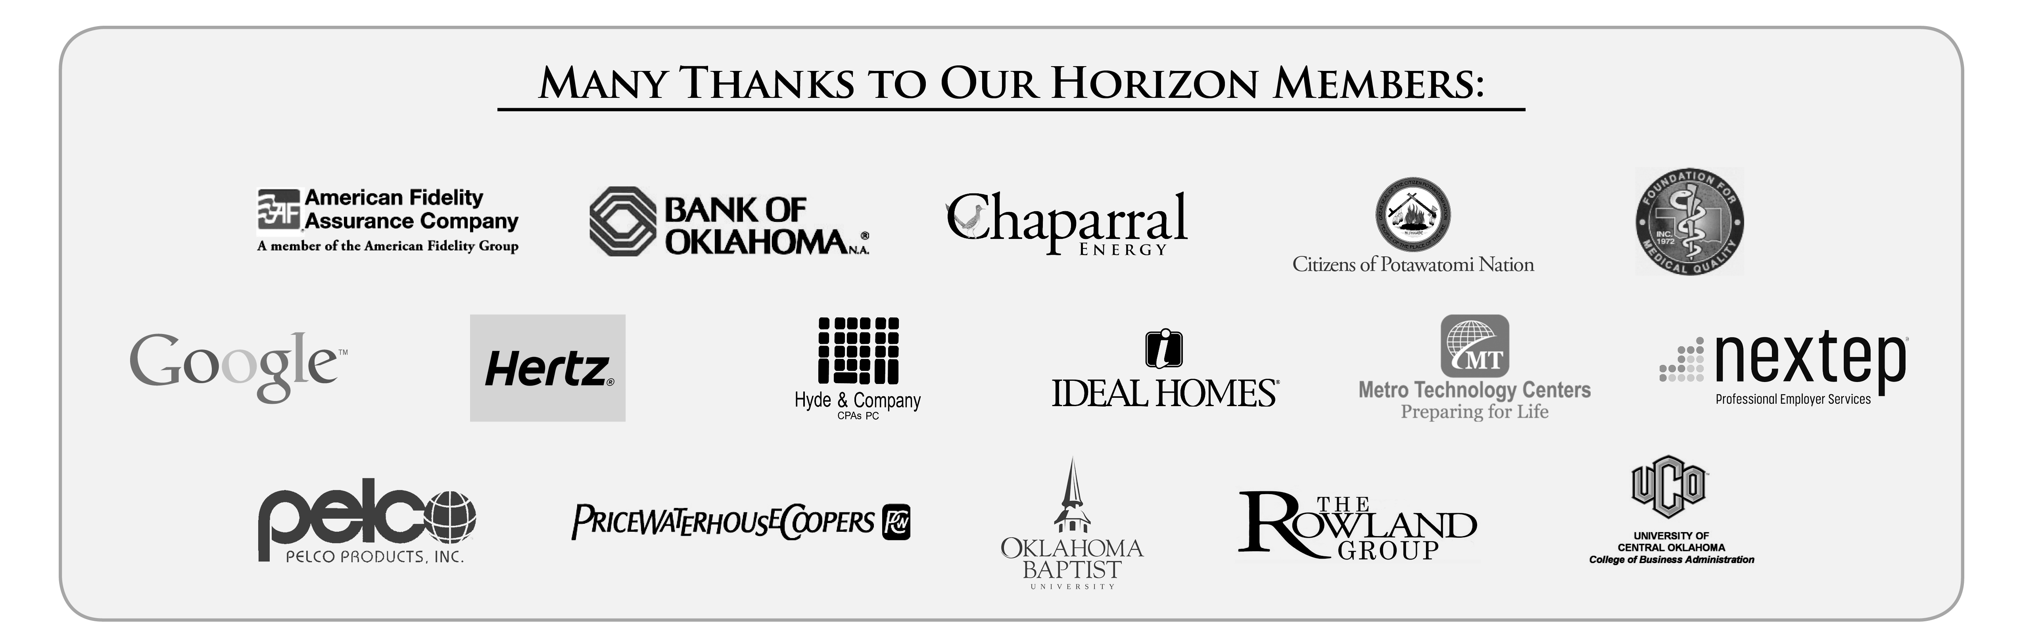
International speaker Stephen M. R. Covey is the New York Times and #1 Wall Street Journal bestselling author of The Speed of Trust: The One Thing That Changes Everything. He is the former CEO of Covey Leadership Center, which, under his stewardship, became the largest leadership development company in the world and today, as FranklinCovey, teaches trust in more than 100 countries.
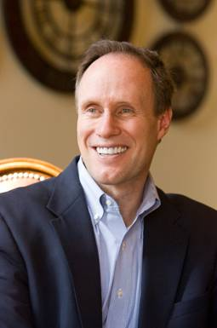 | 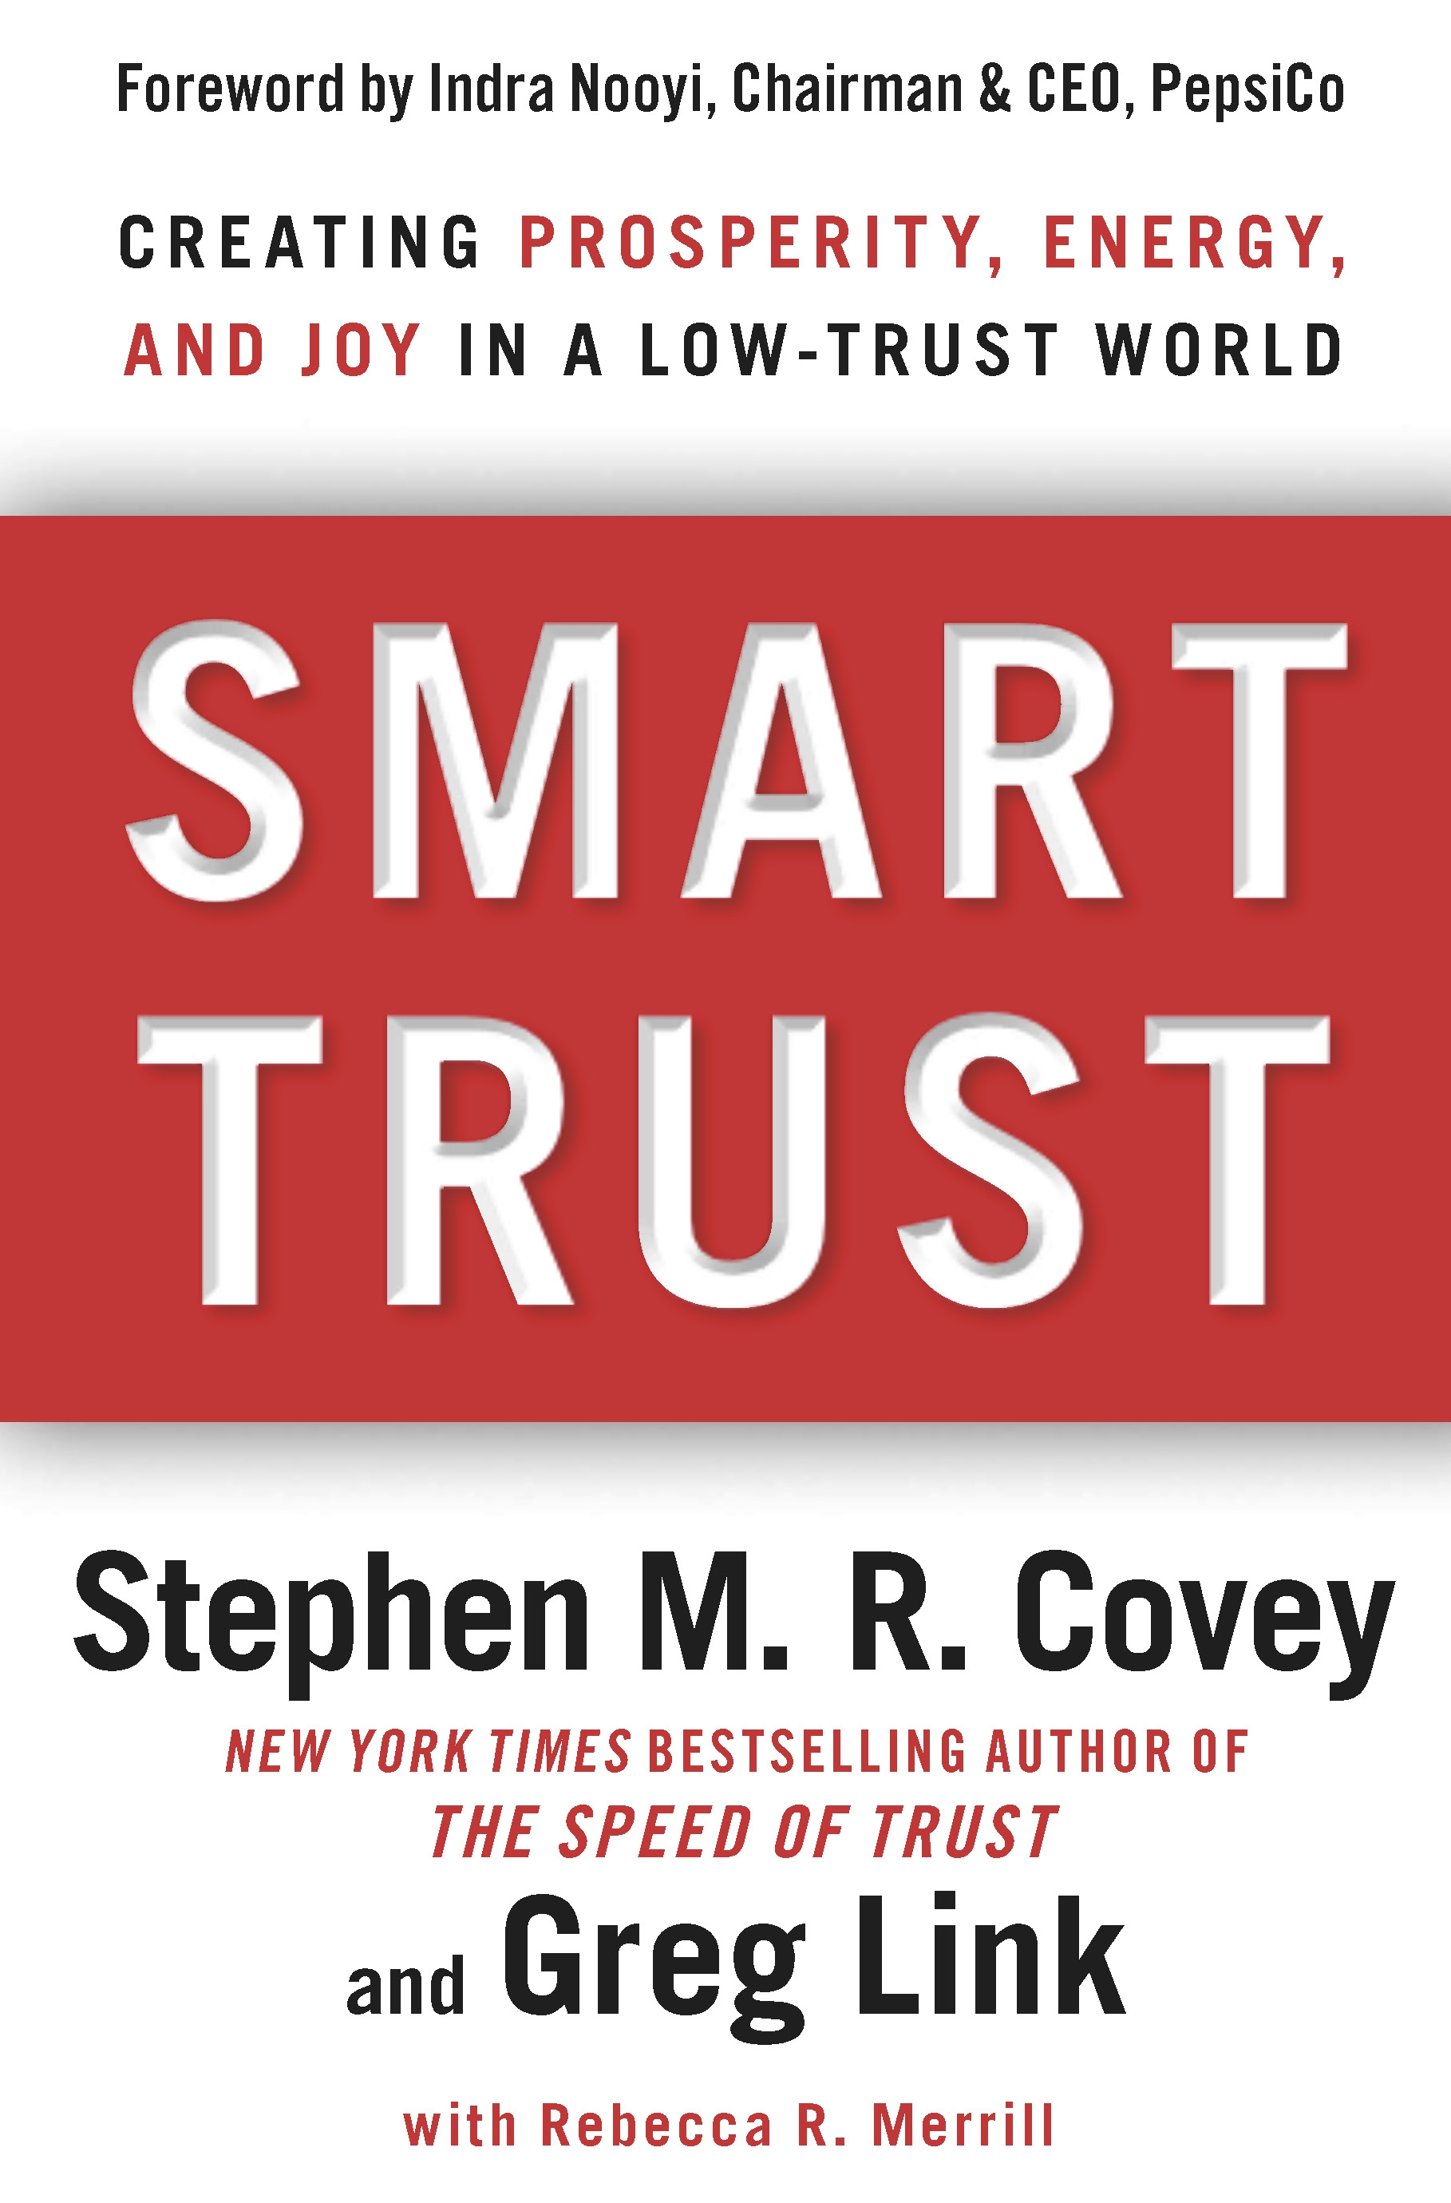

Hats off to Oklahoma’s future
Students present with us today:
- Metro Technology Centers
- Oklahoma City University
- Oklahoma State University
- The University of Central Oklahoma
- The University of Oklahoma
Students hosted by Chesapeake Energy, Hobby Lobby and Principal Technologies.
General Program Disclaimer:
Members of the Oklahoma Business Ethics Consortium frequently share information concerning various issues and developments that may have legal implications. The discussions, commentary, and handouts at Consortium meetings or presentations to other organizations are for general informational purposes only. They cover only some aspects of the subject topic, and do not constitute a complete legal analysis of the topic or how it might apply to any particular set of facts. Before taking any action based on information presented during a Consortium event, participants are encouraged to consult a qualified attorney. The observations and comments of presenters at Consortium meetings and networking are the views and opinions of the presenter and do not constitute the opinion or policies of the Consortium or any of its members. Presenters are respectfully requested to avoid profanity, preaching, politics, put-downs and self-promotion during their lectures

REMINDER: PLEASE PICK UP CPE’S
AT CONCLUSION OF EVENT.

VOLUNTEER RECOGNITION:
Special thanks to Heather Griswold, the Oklahoma Quality Foundation and John Reid of the Oklahoma Business Round Table for their efforts. Also, we appreciate the extra efforts made by David Kelly, St. Luke’s staff and his team, as well as the volunteers assisting with the book sales.

We are deeply grateful to Kellian Schneider of FullForce Branding and Marketing for the great job she did on this year’s Compass Awards program!

OK Ethics relies primarily on volunteers to achieve the organization’s successful pursuit of Oklahoma’s values of integrity at work. It takes leadership and teamwork to host these exciting events!
Join our team - Contact our leadership
WRITERS NEEDED
To prepare copy for upcoming announcements on the True Oldies 99.7FM station. Contact Shannon Warren (see info below)
Membership & Recruiting: Shannon Warren, Founder, OK Ethics
warrenokla@cox.net or 858-2233
Ambassadors: Linda Streun, Director of Human Resources,
Ideal Homes, lindastreun@ideal-homes.com
Registration: Mark Neumeister, D. R. Payne; 272-0511; moneumeister@drpayne.com

Registration Team: These dependable individuals show up every month to diligently record our guests’ attendance and handle the collection of fees:
- Mark Neumeister, Chairperson; D. R. Payne & Associates
- Joe Walker, Chairperson (Prepaid members); Wilbanks Security
Team Members:
  - Mary Kay Huggard, Principal Technologies, Inc.
  - Susan Pate, Stinnett & Associates
  - Mary Vaughn, CPA
  - Brandon Weldon, SandRidge Energy
Ambassador Team: These friendly people welcome our guests each month and assist in helping them locate seats. They also arrive early to help distribute agendas and assist with name tags.
Team Leader: Linda Streun, Ideal Homes of Norman: Chairperson
Team Members:

- Kristy Boone – Ideal Homes
- John Burnett – Character First
- Jamie Gorman- Hyde and Company
- Wayne Hart – Legal Shield
- Jenny Hatton - Boeing
- Brent Martens – Accounting Principals
- Tammy McKeever – Enterprise Holdings
- Lana Melton – Oklahoma Baptist University
- Jacob Pasby – Grant Thornton
- Bobby Redinger – Cole & Reed
- Connie Root – Walker Cos.
- Bill Turner – Valir Health
- Lynn Willis – Metro Technology Centers
- Daniel Yunker – Kimray, Inc.

Agendas: Metro Technology Centers, Quality Services and Media Departments
Accounts Receivable Reconciliation: Susan Pate, Stinnett & Associates
CPE’s: Michael Mount, CPA, Oklahoma Accountancy Board
Facilities & Logistics: Jamie Potter, Eide Bailly
Name tags: Sue Miller, Accel Financial Services
Member Care Coordinator: Jalisha Petties, Accounting Principals
Pre-meeting slide show & AV: Connie Rutz, Maximum MultiMedia & Andrew Keller, Kimray, Inc.
UPCOMING OK ETHICS EVENTS: OKLAHOMA CITY CHAPTER
Returning to the Petroleum Club, downtown OKC
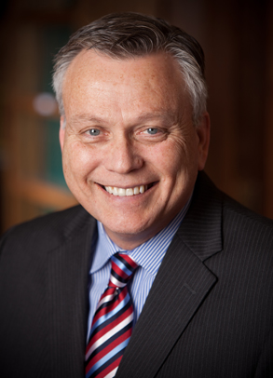  Jim Priest is a husband, dad, attorney and ordained minister in the Church of the Nazarene. He has practiced law in Oklahoma for over thirty years and has been consistently recognized as one of the best lawyers in the nation. In February 2011, Jim became the Executive Director of the non profit organization FATE (Fighting Addiction Through Education) www.fate.org. | May 9  “An Ethical Approach to Substance Abuse”  Professor Steven Mintz, founder of the website, Workplace Ethics Advice, writes: “I teach my students about business ethics and social responsibility. Businesses have a responsibility to provide for a safe workplace and to deal quickly and effectively with behaviors that potentially harm an employee, fellow employees, and those in the community. Providing for an alcohol and substance abuse-free workplace requires a commitment to ethical behavior.”  An ethical approach to substance abuse in the workplace requires more than a drug testing program and firing employees who flunk. So how do you do it? How do co-workers deal with fellow employees who use-- without feeling like a "snitch"? This presentation will provide you with “the ol’ how-to” and will raise your consciousness, lower your fears, and cement your resolve to take the initiative in dealing ethically and effectively with substance abuse.

Watch for details: | Dr. Don Betz, President  University of Central Oklahoma  August 8, 2012 | 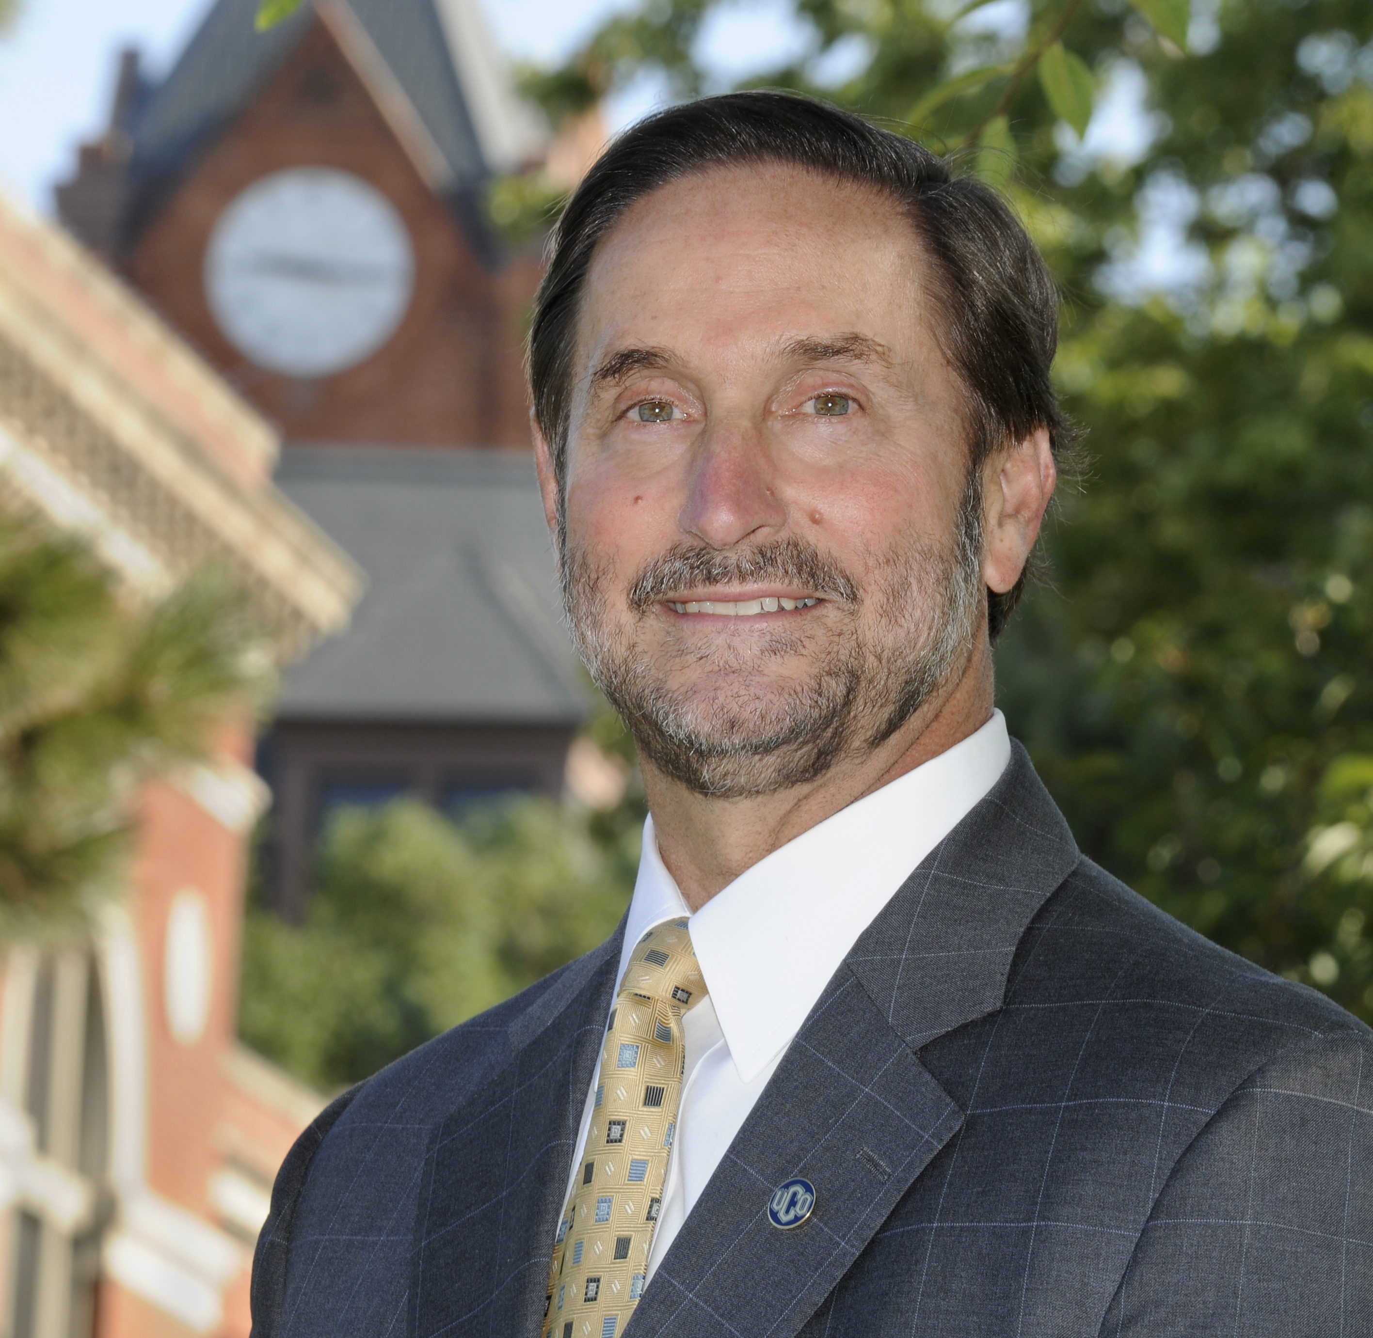

UPCOMING OK ETHICS EVENTS: TULSA CHAPTER
OSU Professor  Andrew Urich, JD  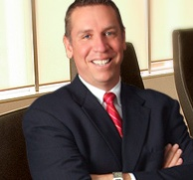  May 24, 2012 | "Doubting, Worrying & Wondering:  The path to ethical decision-making is awareness"  Professor Urich is concerned about the trend among people who stand up in society and tell others how to behave -- they sometimes are embarrassed, disgraced or arrested. In studying the complexity of ethical decision-making, he has identified awareness as the key factor. As an ordinary person, trying to be ethical, Andrew will argue that doubting, worrying and wondering is truly the best strategy to avoid embarrassment, disgrace and arrest.  Bonus: As part of Professor Andrew Urich's research on ethical decision making, he stumbled upon the secret to happiness. You will not want to miss Professor Urich's entertaining and engaging presentation.  Puterbaugh Professor of Ethics and Legal Studies  Spears School of Business, Oklahoma State University

Programs Focused on Integrity - (Not affiliated with OK Ethics)
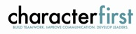
For nearly nine years, we have been inspired by our friendship with Character First. Leaders with this organization provided the wisdom and insight for OK Ethic's Guiding Principles. Go to www.characterfirst.com to learn more about tools to help you integrate character and ethics into your organizational culture, or contact John Burnett at 405-815-0001

“Preventing Workplace Harassment”
Character First Full-Day Leadership Seminar
Thursday, April 19, 2012 | Oklahoma City
Harassment comes in many forms—including bullying, bribery, and blackmail. Learn how to develop a workplace culture that prevents harassment before it starts, catches it when it occurs, and responds in ways that address the character issues, not just the action.

Character Council of Central Oklahoma …cultivating good character
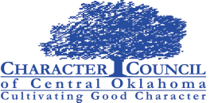
The Character Council of Central Oklahoma is an organization that educates, equips and empowers others to create a culture of good character within Central Oklahoma. Their vision is that Central Oklahoma will become a model community of good character. Upcoming programs include:
April 24: Tony Kennedy – President, Oklahoma Baptist Home for Children
May 22: James Lankford – Representative, United States Congress
Cost is $15 per person; Reservations made via luncheon@characterok.org

INTERESTED IN RECEIVING OK ETHICS MONTHLY MEETING NOTICES?
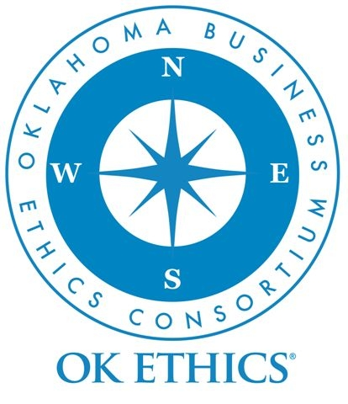
OKC: Contact Jalisha Petties,
Member Care Coordinator
at (405) 889-0498
or via email
okethics@yahoo.com

Tulsa: For more information about Tulsa activities, contact Michael Oonk,
President – Tulsa Chapter
(918) 481-3822

Promoting Oklahoma values Like OK Ethics on FaceBook
of integrity at work!

