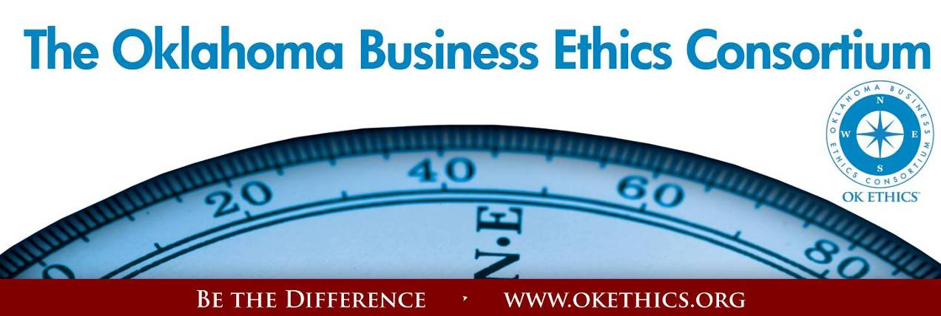
Agenda – September 12, 2012
- Membership Drive – Garyl Geist, Chief Operating Officer, Oklahoma Asthma
& Allergy Clinic; President, OK Ethics (State) Board of Directors

Special thanks to KIMRAY & SANDRIDGE ENERGY
AS OUR NEWEST PINNACLE MEMBERS!
PACESETTERS FOR FY12-13!
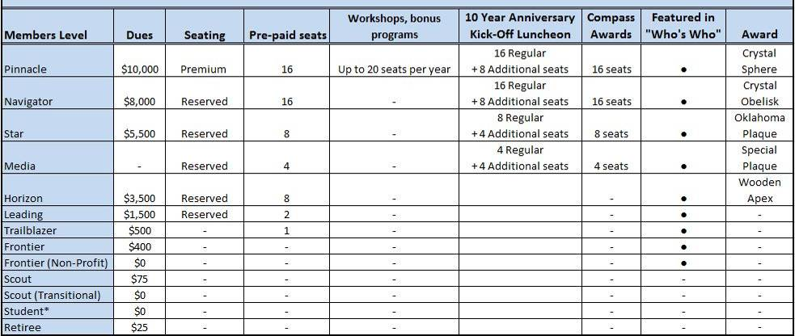

II. Book Signing immediately following program; Make $20 checks payable to Character First;
credit cards accepted, too.
III. Student/Educator Initiatives – Shannon Hiebert, Vice President of Human Resources, Enterprise Holdings;
President, OK Ethics Foundation
STUDENT ETHICS CHALLENGE
October 13 – UNIVERSITY OF OKLAHOMA: MODERATORS NEEDED!
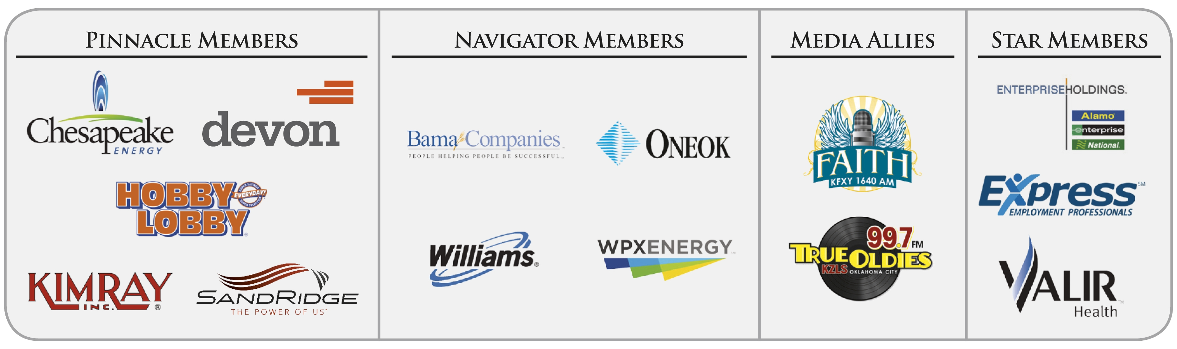
UPDATE: Symposium was a huge success! Approximately 70 leaders in education representing about 20 campuses from across the state attended this statewide endeavor!

IV.VOLUNTEER RECOGNITION:
OK Ethics relies primarily on volunteers to achieve the organization’s successful pursuit of Oklahoma’s values of integrity at work. It takes leadership and teamwork to host these exciting events!

Registration Team: These dependable individuals show up every month to diligently record our guests’ attendance and handle the collection of fees:
- Mark Neumeister, Chairperson; D. R. Payne & Associates
- Joe Walker, Chairperson (Prepaid members); Wilbanks Security
Team Members:
  - Mary Vaughn, CPA, JMA Energy
  - Mary Kay Huggard, Principal Technologies, Inc.
  - Marvinette Ponder, Devon Energy
Ambassador Team: These friendly people welcome our guests each month and assist in helping them locate seats. They also arrive early to help distribute agendas and assist with name tags.
Team Leaders: John Burnett, Character First and Linda Streun, Ideal Homes of Norman
Team Members:
- Chris Ferguson, Oklahoma Funeral Board
- Jamie Gorman, Hyde & Company
- Jenny Hatton, Boeing
- Valorie Hodges, Valir Health
- Jacob Pasby, Arnold Oil Properties
- Bill Turner, Valir Health
- Daniel Yunker, Kimray, Inc.
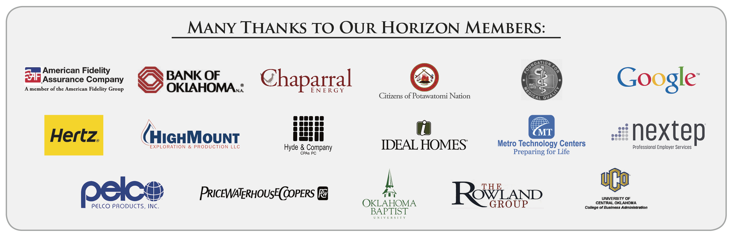
Accounts Receivable Reconciliation: Susan Pate, Stinnett & Associates
Book Sales: John Burnett and Bryan Clifton, Character First
CPE’s: Michael Mount, CPA, Oklahoma Accountancy Board
Facilities & Logistics: Jamie Potter, Eide Bailly
Name tags: Anna Rosenthal, Accounting Principals
Member Care Coordinator: Jalisha Petties, Accounting Principals


- Upcoming Events: Oklahoma City Chapter Shannon Warren, Founder, OK Ethics
TUNE IN! Our own Bob Byrne and Shirley Mears will soon be featured on the morning drive for True Oldies Channel 99.7. We will keep you posted as to when the ads are ready for release!

October 10, 2012 – Welcome back Tom Hill of Kimray, Inc.

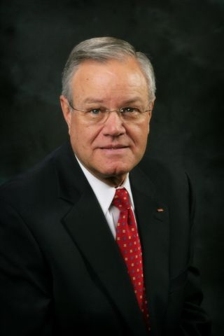
“Building Ethical Muscle”

Recommended for 1 CPE in Ethics
Mastering a skill takes practice.
Mr. Hill will provide insights on how to achieve optimal levels,
especially when confronted by those who don’t play by the same rules.

We are pleased to welcome OK Ethics first Executive Pilot Award recipient back to our podium. Since receiving this honor in April, 2010, Mr. Hill has authored a book Making Character First. Also, Kimray has been featured in the PBS documentary, Doing Virtuous Business.

Mr. Hill has been a good friend to OK Ethics since the beginning, sharing his insights for the development of our charter and Guiding Principles. He is the founder of the Character First program, designed to help employees reach their full potential as individuals. Kimray’s character emphasis is world-renowned, being used in over 27 countries and translated into 11 languages.

Kimray is a manufacturer of control valves and related equipment for oil and gas producers. Established in 1948, the company has staying power, which is largely attributable to doing the right thing. In less than two years after implementing Character First, Kimray’s Worker Compensation costs decreased 80% and they experienced a 25% increase in profits. Kimray has demonstrated that business excellence goes well beyond the financial, but also into the personal commitment to integrity by each member of their company

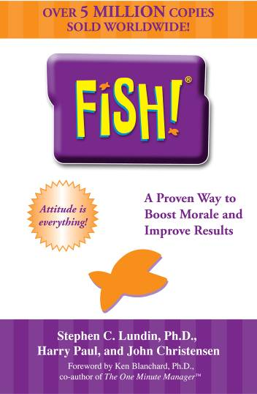
November 15, 2012 - OK ETHICS LAUNCH OF 10 YEAR ANNIVERSARY!
LUNCHEON - OKLAHOMA GOLF & COUNTRY CLUB
Fish! and The Power of Ethics
presented by
Harry Paul, co-author Fish!
Presented by Harry the Fish! Guy; co-author of the best-selling book that creates fun at work while maintaining one’s integrity. With a Ph.D. in experience, Harry worked with Ken Blanchard and collaborated with Norman Vincent Peale on the launch of the book, The Power of Ethical Management. You will leave this session feeling invigorated and inspired!
A separate, special interactive morning session will be offered through the Peer Learning Network at Southern Nazarene University. Visit http://ziglarcenter.com/events for further information and registration.
Recommended for 1 CPE in Ethics

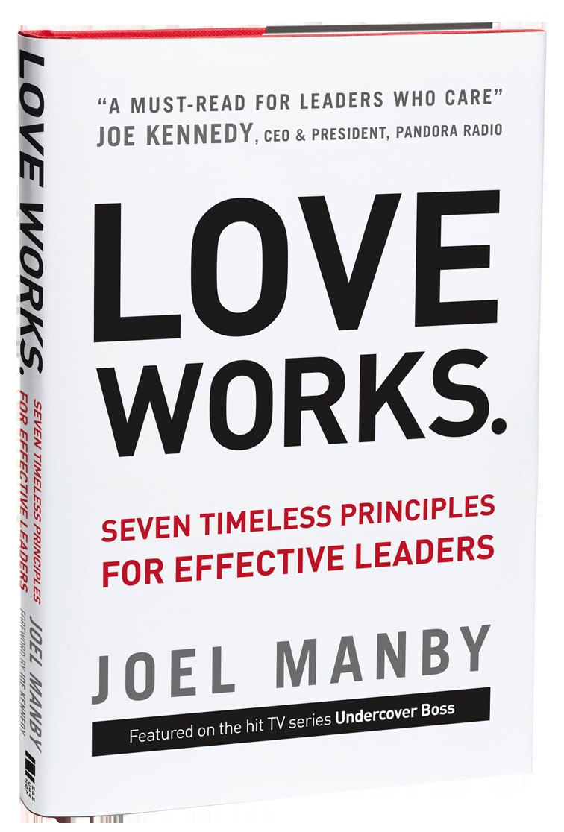
Help spread the word:
Please post Upcoming Events on your company’s bulletin board.
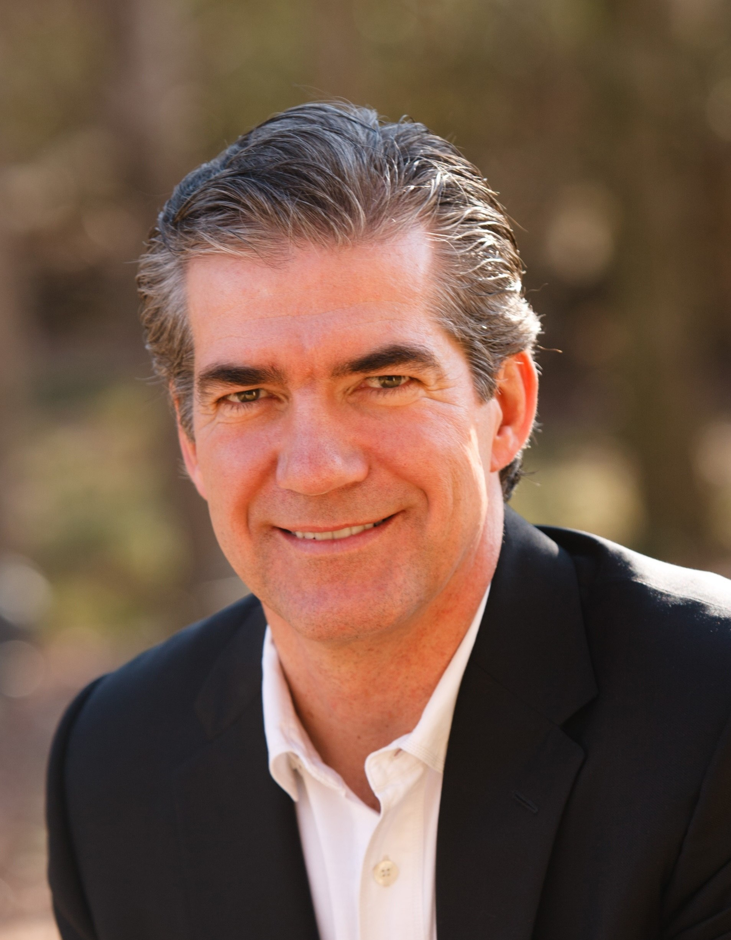
NOTE DATE CHANGE:
Friday, December 7

Joel Manby
President and CEO,
Herschend Family Entertainment Corporation (HFE)

Joel Manby is President and Chief Executive Officer of Herschend Family Entertainment Corporation (HFE). It is the largest family-owned theme park corporation in the U. S. with 26 properties in ten states.

You may have heard of Mr. Manby because he starred on the CBS hit show Undercover Boss.
Manby and the employees of HFE moved millions of viewers across the world with their unique approach to leadership. He now shares the principles that make HFE successful in his new book, Love Works.

Manby has incorporated the definition of love the verb into the company’s existing organic culture to establish how leaders are to behave. He views love as a mode of thinking – one that has helped him deliver tangible results and position his company as the 9th largest themed attractions company in the world.

An expert on leadership and customer relations, he spent 20 years in the auto industry. Manby was a member of the start-up team for Saturn Corporation, followed by a successful career as CEO of Saab Automobile USA where sales increased by 67% and their J.D. Power Quality Rating improved from 30th to fifth in the industry.

As valedictorian of Albion College, Manby was a Rhodes scholarship finalist. He earned an MBA from Harvard Business School and his involvement with his alma mater has continued throughout his career.

Mr. Manby will be available for book sign immediately after the program. Cost of book TBD.

Many thanks to our friends at Strata Leadership for making this happen!

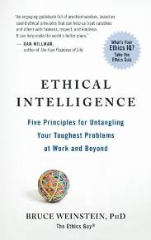
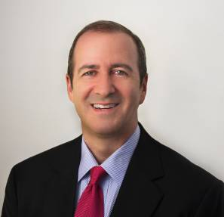
TULSA CHAPTER ACTIVITIES: September 27
"Ethical Intelligence™: How Good People Make Great Things Happen"

presented by
Bruce Weinstein, Ph.D., The Ethics Guy

Tulsa Chapter (Continued)
October 25
"A Champion's Perspective" presented by Jay Wilkinson, son of legendary OU Coach Bud Wilkinson
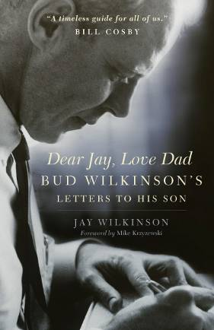
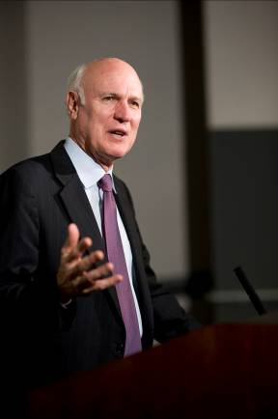

VI.Today’s Guiding Principles & Discussion Topic:
Presented by Bill Blew, The Olive Branch & Peacemaker Facilitator
- Encourage the promotion of ethical behavior through personal actions and sharing ideas and resources.
- We respect other members by:
  - Exhibiting listening skills and actively listening to discussions.
  - Being open to other points of view and outcomes.
  - Realizing that each of us is in a mode of continual learning, we demonstrate humility, care and compassion when sharing our thoughts and knowledge.
  - Speak the truth with confidence and encourage others to do the same.

How would you handle this situation?
Sally serves with you as a member of a close-knit non-profit committee. Recently, she posted some inaccurate information on your Facebook page. You responded with a cordial message indicating that the situation had changed and thought she’d want to know. She reacted with sarcasm and, when you tried to explain that you had no political interest in the matter, she promptly unfriended you and advised you not to contact her again. Since that time, Sally will not speak to you and tension is felt on the committee.

It’s never easy to speak the truth, even if done gently. What do you do in a situation like this?
      - What are the potential ramifications of not speaking up?
      - Being mindful of the Guiding Principles outlined above, how might you attempt to restore a positive working relationship with Sally?

Some pointers for ethical conflict resolution based on Peacemakers:

- Go to higher ground. See conflict as an opportunity to grow and demonstrate your highest values.
- Take responsibility. Keep your attitude in check so that you are able to listen with an open mind. Be sure that you have your facts straight and are humble in your approach.
- Overlook minor offenses. Talk privately, demonstrating concern for the other person. Something else might be bothering them.
- Strengthen relationships through genuine reconciliation and agreement. This can be achieved by first ascertaining the interest of others. Be forgiving.
- Finally, do the right thing – regardless of what the other person does.

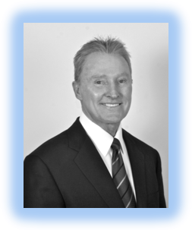
About our presenter: MICK UKLEJA
Mick Ukleja, co-author of The Ethics Challenge: Strengthening Your Integrity in a Greedy World will share insights that will help individuals move beyond compliance into a courageous leadership methods that transform organizations. His ideas have been praised by prominent leaders such as business guru Tom Peters who said, “Please read The Ethics Challenge. Please act on it. Your professional and family life alike literally depend on it.”

Ken Blanchard said of the book: “When you read The Ethics Challenge, you’ll see that ethics is alive and well in America. Bob and Mick have written an important book for today’s leaders.”

Mick is the founder and president of Leadershiptraq, a leadership-consulting firm based in Southern California. Of particular interest to our university advisors is his role in founding the Ukelja Center for Ethical Leadership at California State University in Long Beach. He holds a B.A. in philosophy, a masters degree in Semitic languages and a Ph.D. in theology. His business experience combined with education has given him a fresh perspective on dealing with ethical issues.

His last book, Who are You and What Do You Want? Four Questions That Will Change Your Life, was praised by legendary coach John Wooden. He has also written books about Managing the Millenials and has worked with a wide variety of clients such as Boeing and the Special Olympics.

Mick is Chairman of the Board of Trustees for the Astronauts Memorial Foundation at the Kennedy Space Center which oversees the center for space education. He has been featured on Fox News, CNN, Fox Business Network, NBC, and numerous publications.

Why is it that so many of the nicest people aren’t as ethical as they think they are?

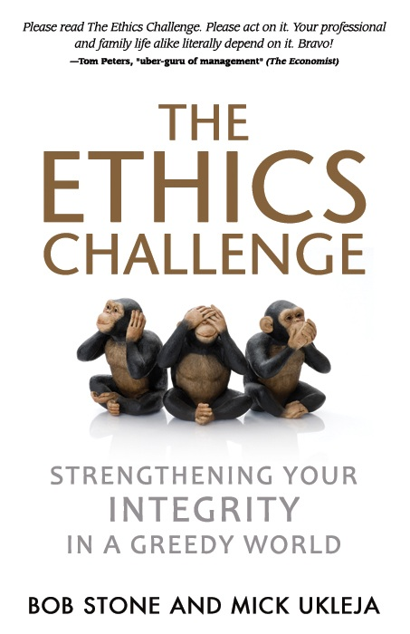

The Ethics Challenge:

Integrity Wins: Facing “The Herd”
E = Embrace your purpose

T = Test excuses

H = Harness your moods

I = Insist on integrity

C = Cultivate trust

S = Self-differentiate

Ever face being trampled by “The Herd” – those who don’t want to play by the rules and will run over anyone who gets in their way? Learn the key components of building emotional shields that will help strengthen your character in the face of ethical challenges:

- Where We Are Today:

➢ Current Attitude of Americans
75% - Feel Corporate Corruption On The Rise
62% - Feel Corporate Corruption Is Epidemic
20% - Trust The Banking System
➢ Public Attitudes toward Media are Declining
➢ Greater Distrust in Politics
➢ Recent Headlines: “Harvard Says 125 Students May Have Cheated on a Final Exam”

- Ethical Knowledge*

- Ethical Knowledge: Codes, rules, knowing right from wrong
- Ethical Courage: Execution in the midst of pressure
- Ethical Conduct: Behavior that aligns with knowledge

*Dr. Ned Hill, Dean of Marriott School of Management, Brigham Young University

- Ethics Is An Inside Job
- Embrace A Purpose: Involves Obedience to the Unenforceable
- Test Your Excuses:
Ethics: Conduct:
No Lying No Whining
No Cheating No Complaining
No Stealing No Excuses

- Harness Your Moods

Self-Awareness:
The ability to read your own emotions and accurately assess your own personality.

Self-Management:
The ability to keep destructive emotions under control.

- Insist on Integrity

Do The Right Thing…

Do It Right…

Do It Right Now!

- Cultivate Trust

Trust equals=

Keeping simple agreements
Plus +
Doing No Harm

- Self-Differentiate

Maturity Equals…

The willingness to take responsibility for your own emotional being and destiny.

General Program Disclaimer:
Members of the Oklahoma Business Ethics Consortium frequently share information concerning various issues and developments that may have legal implications. The discussions, commentary, and handouts at Consortium meetings or presentations to other organizations are for general informational purposes only. They cover only some aspects of the subject topic, and do not constitute a complete legal analysis of the topic or how it might apply to any particular set of facts. Before taking any action based on information presented during a Consortium event, participants are encouraged to consult a qualified attorney. The observations and comments of presenters at Consortium meetings and networking are the views and opinions of the presenter and do not constitute the opinion or policies of the Consortium or any of its members. Presenters are respectfully requested to avoid profanity, preaching, politics, put-downs and self-promotion during their lectures

REMINDER: PLEASE PICK UP CPE’S
AT CONCLUSION OF EVENT.

Programs Focused on Integrity - (Not affiliated with OK Ethics)

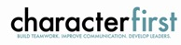
For nearly nine years, we have been inspired by our friendship with Character First. Leaders with this organization provided the wisdom and insight for OK Ethic's Guiding Principles. Go to www.characterfirst.com to learn more about tools to help you integrate character and ethics into your organizational culture, or contact John Burnett at 405-815-0001

Seminar Oct 16: "Coaching & Mentoring at Work"
What if you could make "people development" instead of "people problems" part of your everyday experience? Part of developing your workforce is coaching employees to achieve personal and professional goals—and that benefits the whole organization. This might include enhancing specific business behaviors, managing organizational change, solving complex problems, or correcting specific issues.
Hear Joel Parker, Lyn Watson, and Dr. Nathan Mellor explain how to:
● Make “business coaching” part of your personal leadership style.
● Focus coaching on beliefs and excellence, not just steps of actions.
● Understand high-potential employees and how to lead them to greater success.
● Conduct meaningful coaching experiences using the “C3™ Business Coaching” process.

(This training is designed for mid-level managers and higher. It is recommended for 6 continuing education credits.)
Registration: $395/person for member organizations ($495/person for non-members)
Includes training, materials, and lunch.
Ask about group registrations!
Save $50 if you register by October 5.

Character Council of Central Oklahoma …cultivating good character

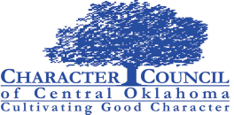
The Character Council of Central Oklahoma is an organization that educates, equips and empowers others to create a culture of good character within Central Oklahoma. Their vision is that Central Oklahoma will become a model community of good character.
Tuesday September 25, 2012 featured speaker:
Keith Watters,
Hobby Lobby Distribution Personnel Manager

Cost is $20 per person; Reservations made via luncheon@characterok.org


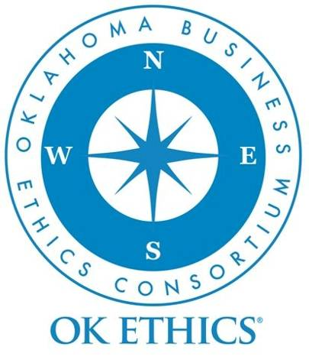
Like OK Ethics on FaceBook

Interested in joining OK Ethics?
Interested in Receiving OK Ethics Monthly Meeting Notices?

OKC:
Contact Jalisha Petties, Member Care Coordinator
at (405) 889-0498 or via email okethics@yahoo.com

Tulsa: For more information about Tulsa activities, contact
Michael Oonk,
President – Tulsa Chapter,
(918) 481-3822

Contact Lynda Mobley, Vice President of Membership
Lynda.Mobley@oneok.com

Interested in serving on a committee?

Contact Shannon Warren, Founder
warrenokla@cox.net or call (405) 858-2233

Want to assist with the Statewide Student Ethics Challenge on October 13?

Contact Shannon Hiebert, President of the OK Ethics Foundation
Shannon.Hiebert@erac.com

